**5 Resume Reviews for Machine Learning**

A review of the 5 most recent resumes asking for review on r/learnmachinelearning

[[Yujian Tang](https://medium.com/@ytang07?source=post_page-----25f608a89230--------------------------------)](https://medium.com/@ytang07?source=post_page-----25f608a89230--------------------------------)

[[Plain Simple Software](https://medium.com/plain-simple-software?source=post_page-----25f608a89230--------------------------------)](https://medium.com/plain-simple-software?source=post_page-----25f608a89230--------------------------------)

[Yujian Tang](https://medium.com/@ytang07?source=post_page-----25f608a89230--------------------------------)

·

[Follow](https://medium.com/m/signin?actionUrl=https%3A%2F%2Fmedium.com%2F_%2Fsubscribe%2Fuser%2F1c4e6640433f&operation=register&redirect=https%3A%2F%2Fmedium.com%2Fplain-simple-software%2F5-resume-reviews-for-machine-learning-25f608a89230&user=Yujian+Tang&userId=1c4e6640433f&source=post_page-1c4e6640433f----25f608a89230---------------------post_header-----------)

Published in

[Plain Simple Software](https://medium.com/plain-simple-software?source=post_page-----25f608a89230--------------------------------)

·

3 min read

·

Dec 20, 2023

55

1

I commonly scroll through r/learnmachinelearning, and recently I’ve seen an uptick in resume review/roast requests. I’ve been working in AI/ML for a while now and seen a bunch of resumes. At this point, I have a pretty good idea for whether or not a resume would get you in for an interview. Remember though, the best way to get in for an interview is through a warm introduction.

The way to improve all of these resumes can be summed up succinctly in four words.

*Less words, more numbers*

Let’s all just take a minute to remember — recruiters are hella busy, and they don’t have *that* much time to be reviewing your resume. Make it easy for them. Okay let’s dive into these. I’ve dropped my comments for each resume right below them.

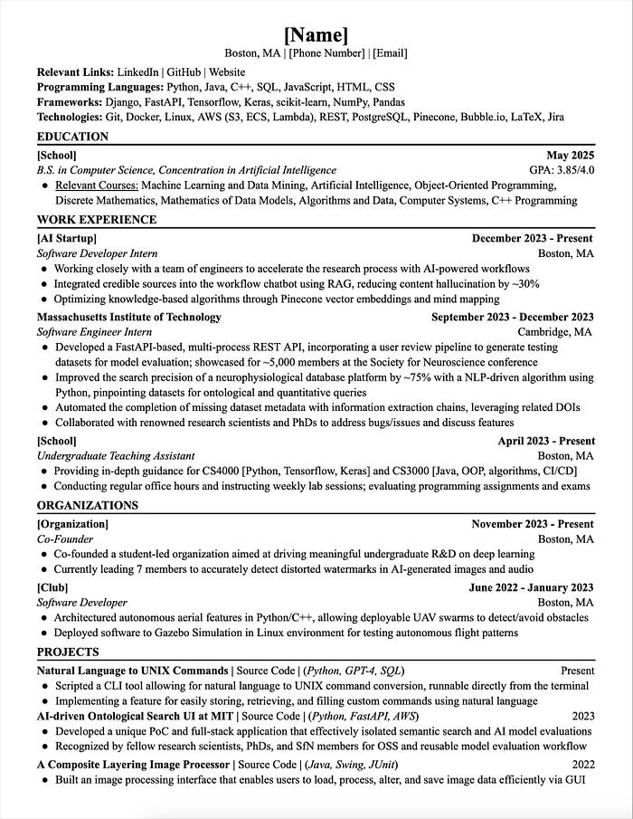

brownjamba30’s Resume

* There are numbers here, nice

Here’s how you make this better

* “Developed a FastAPI-based …” how many processes? how many datasets? how big?
* “Collaborated with renowned …” how many scientists? how many bugs? how many features?
* “Conducting regular office hours …” how many office hours? what times? how many assessments and exams?

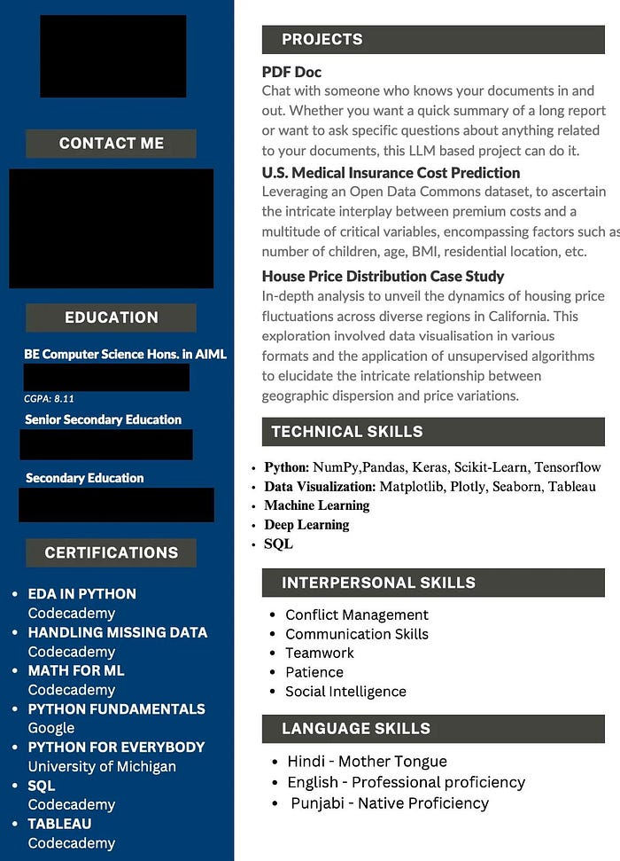

kindly_work_6038’s Resume

* there are no numbers on here at all
* seriously, what
* also the formatting hurts my eyes

How to make it better

* “PDF Doc” — not descriptive, maybe “PDF RAG app” or “PDF Chatbot” or “PDF Q/A” something like that
* “US Medical …” how big was the dataset? what did you learn? what did you predict?
* I have never once in my life looked at the certifications someone has, drop em, this is AI/ML not Law

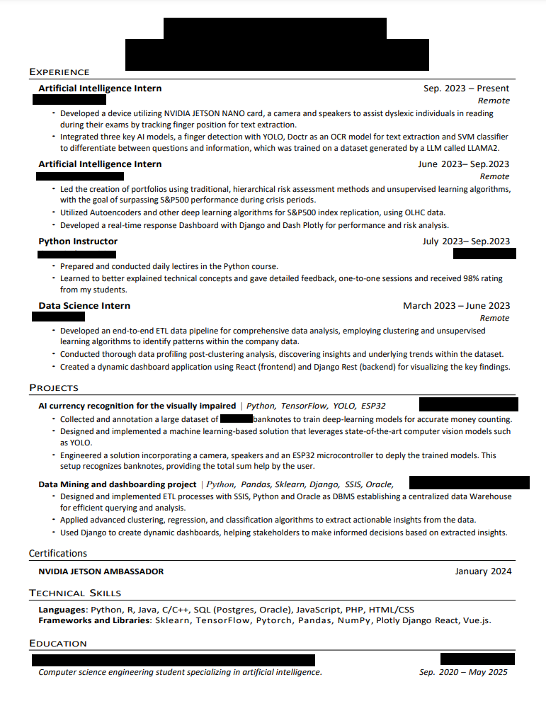

Kahliiil’s Resume

* numbers, but they’re hidden as text

How to make it better:

* “led the creation of …” how many portfolios? how did you do? you’re also missing a comma
* “prepared and conducted daily …” how many lectures? how long were they? how many different topics? how many students?

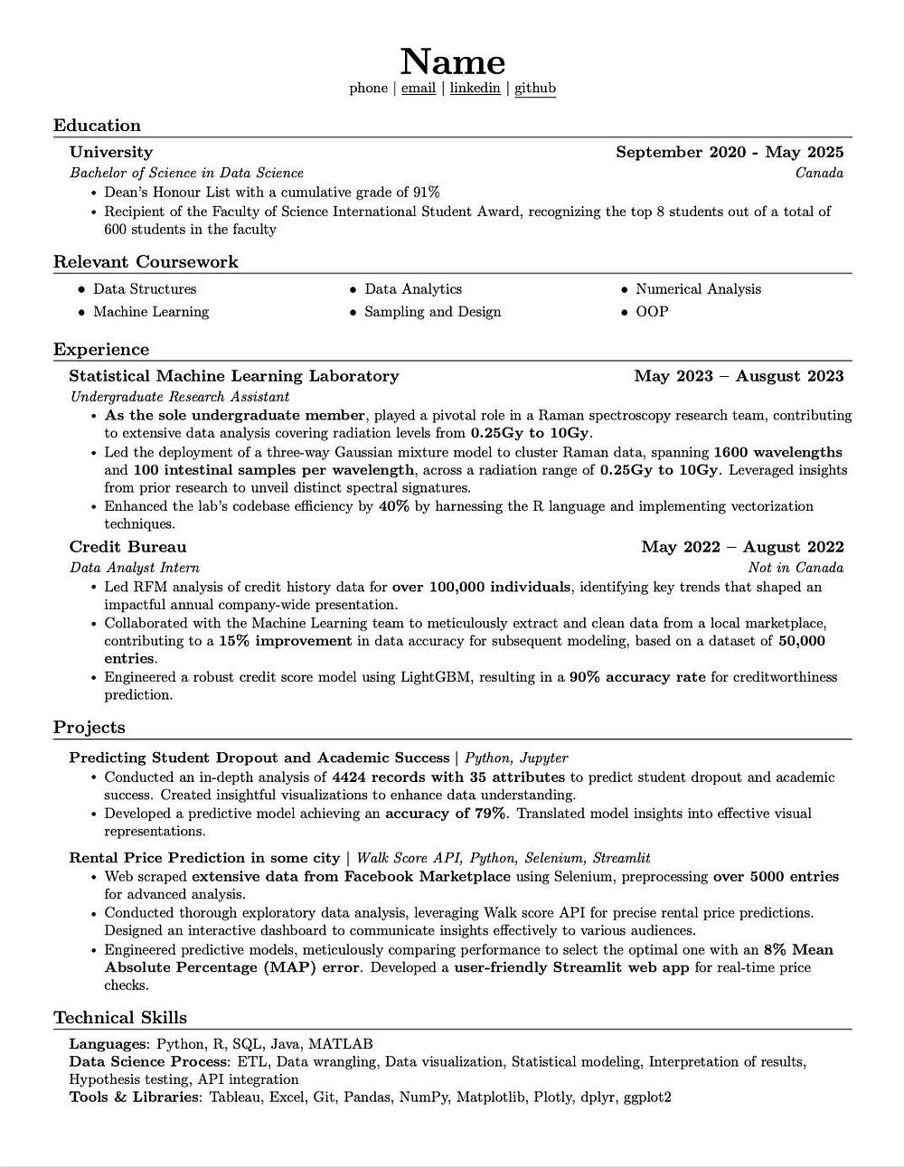

elegant_bad1311’s Resume

* love that there are numbers!

How to make this better?

* Less words, more numbers (still) (“as the sole undergraduate member …” tell me in the interview)
* Use more meaningful numbers (radiation levels from 0.25Gy to 1.0Gy — what’s this gotta do with AI/ML?)
* “Enhanced codebase efficiency …” you’re really gonna have to explain this one

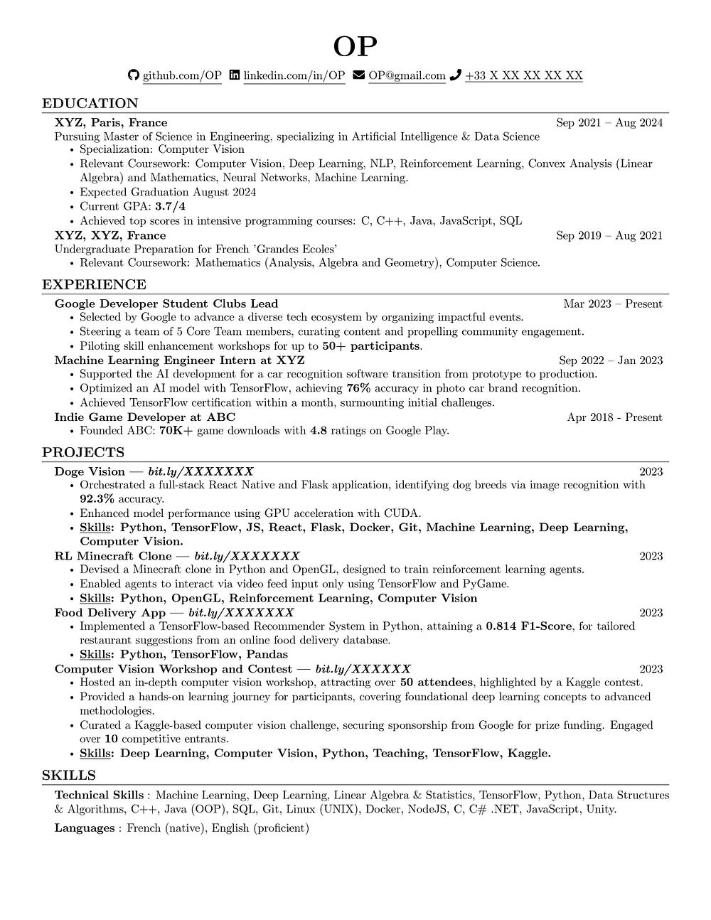

nodropoutwhenconv2d’s Resume

* hey I see some numbers on here too!

How to make it better

* Get rid of words you don’t need (“Achieved Tensorflow … surmounting …”) get rid of the “surmounting …” part, tell me in the interview
* “Enhanced model performance …” get rid of this, you can add “with CUDA” to the statement above
* RL Minecraft Clone — how many agents? what kind of agents? what did you use to orchestrate the agents?

Like this article? Follow me, [Yujian Tang](https://medium.com/@ytang07), for more posts about NLP, Software, and Growth. Make sure to follow [Plain Simple Software](https://medium.com/plain-simple-software) for more software articles too!